**Jenkins Assignment :**

Jenkins Pipeline, create custom pipeline view and control jobs through Build Pipeline plugin interface.

Need to create Dependent freestyle jobs: The First Job, The Second Job, The Third Job. After running The First Job, The Second Job should start automatically and then The Third Job should start automatically after completion of The Second Job

Setup build pipeline view in dashboard.

**Process:**

Logged in to AWS Management Console.  
• Launched EC2 Instance: (virtual machine - Ubuntu).

And security groups to allowed HTTP (port 80) and SSH (port 22) traffic with instance type - T2.medium and 15Gb disk size and created PPK file.

**Connect to Your EC2 Instance**

•    Used SSH to connect to EC2 instance using the PPK file via Putty as below.

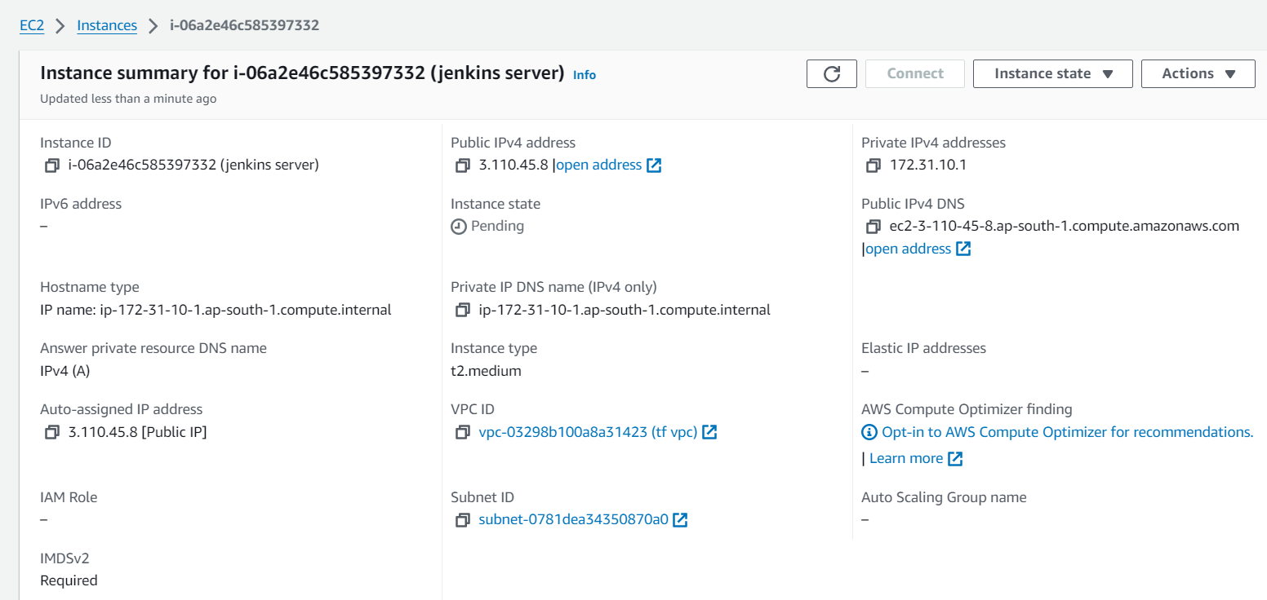

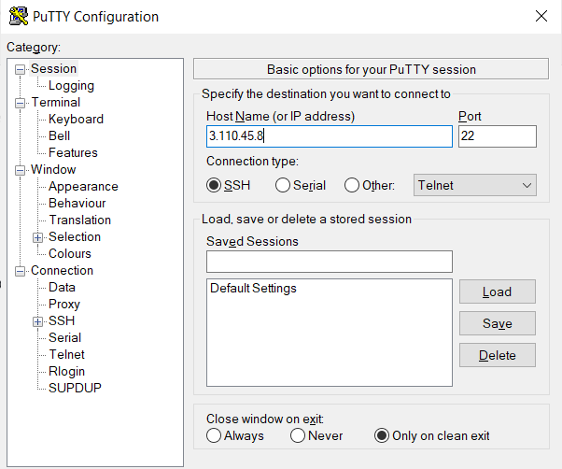

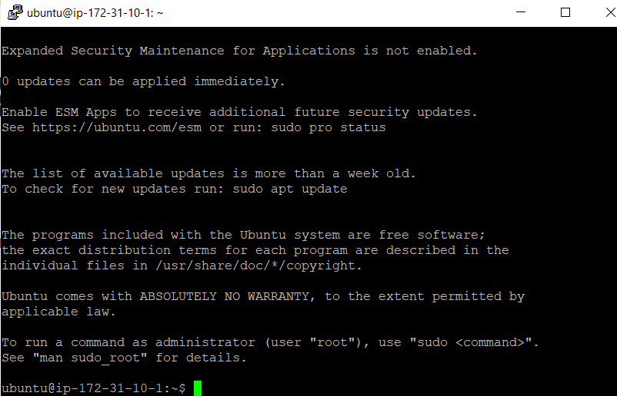

**First need to install Java on to the machine as Jenkins runs on java:**

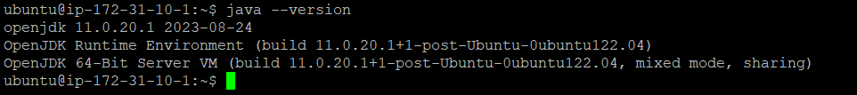

**Installed Jenkins on to the machine as below:**

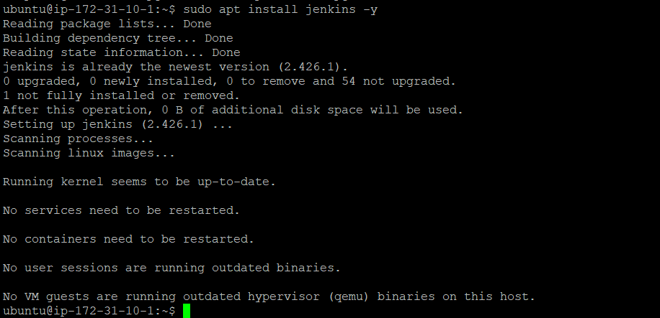

**Added port 8080 entry to the SG**

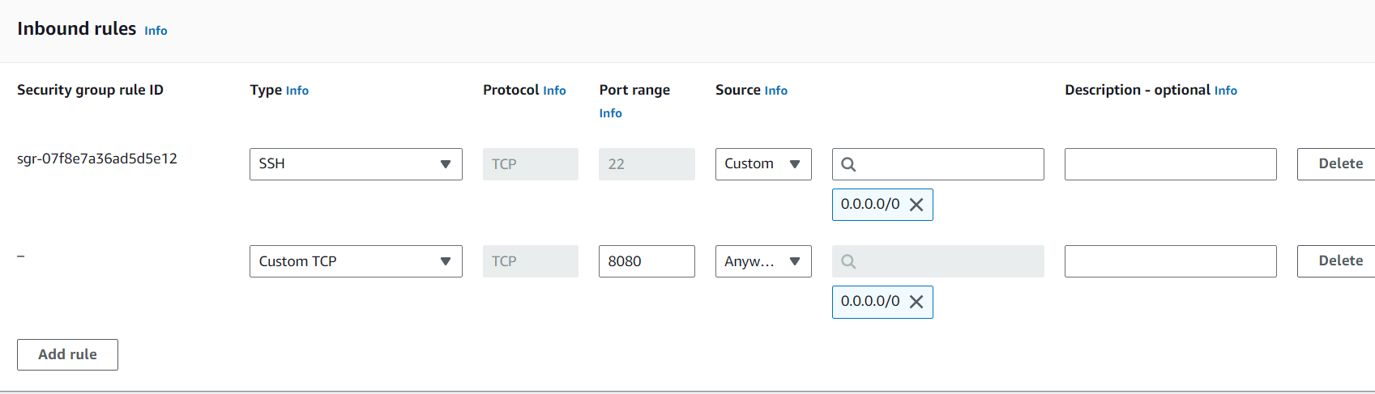

**After adding port entry hit ip-port on to the browser and unlock the Jenkins.**

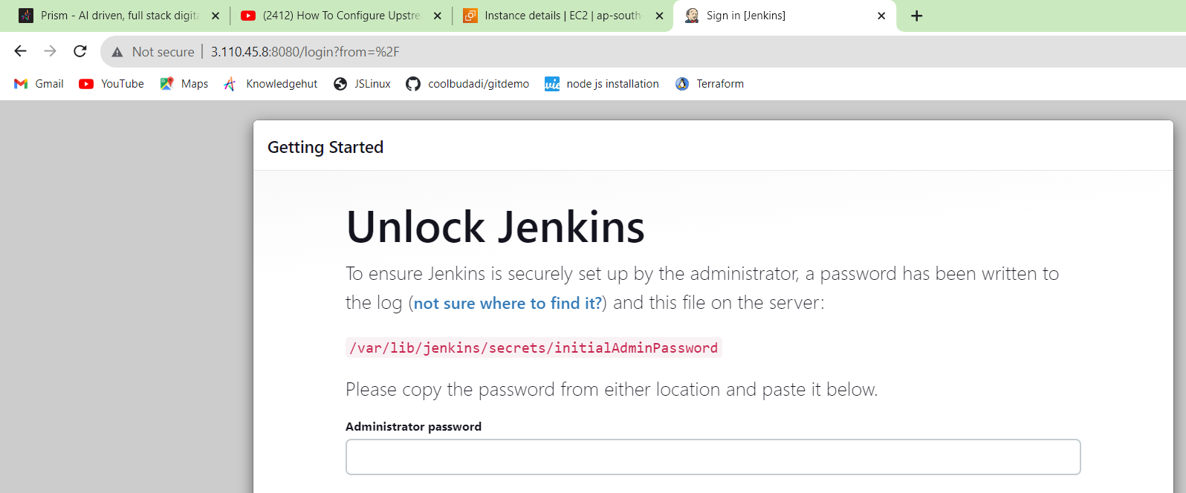

**For administrator password cat the above path and use the content as password as below:**



**Installing required plugins:**

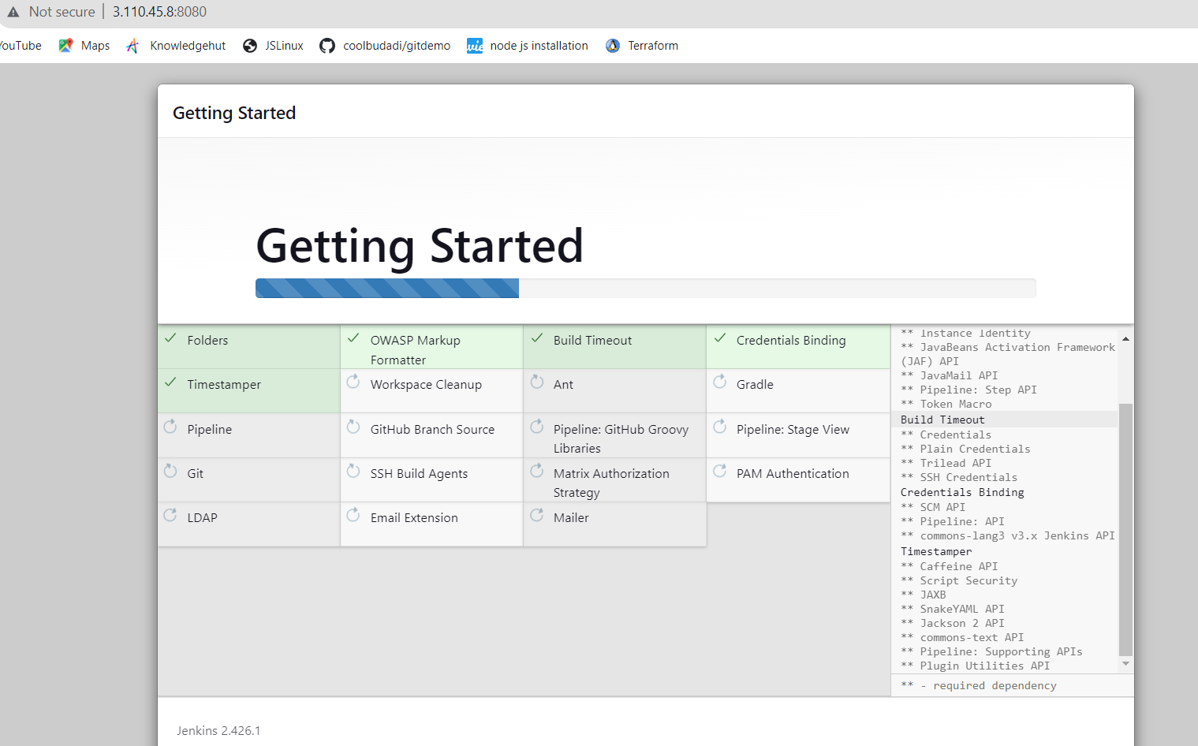

**Settings the username / Password as below :**

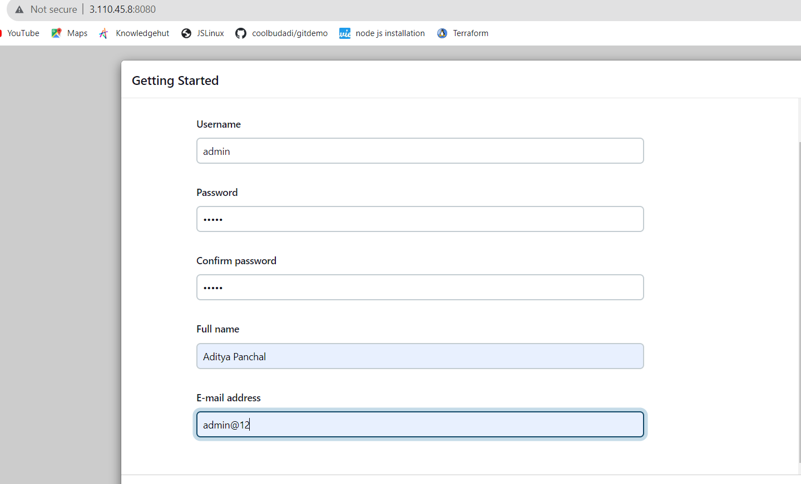

**Now Jenkins ready as below:**

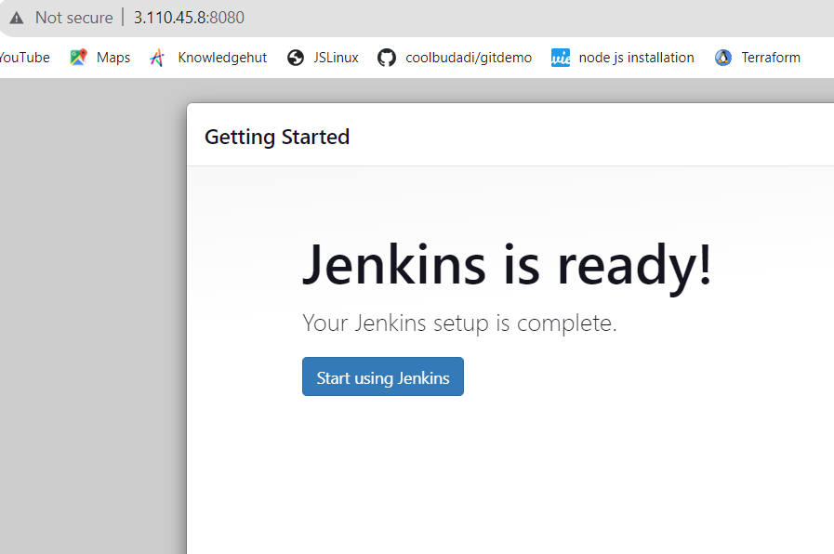

**And Below is Jenkins dashboard which is running on to the port 8080:**

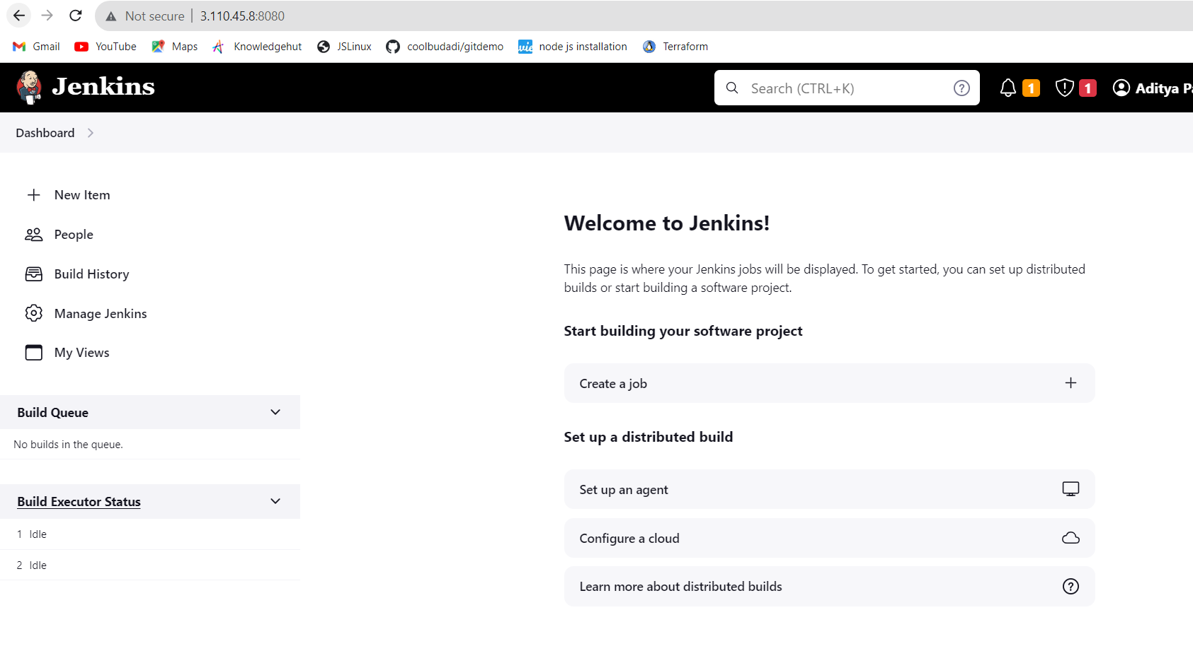

**Installed Plugin “Build Pipeline Plugin” using Jenkins plugin manager**

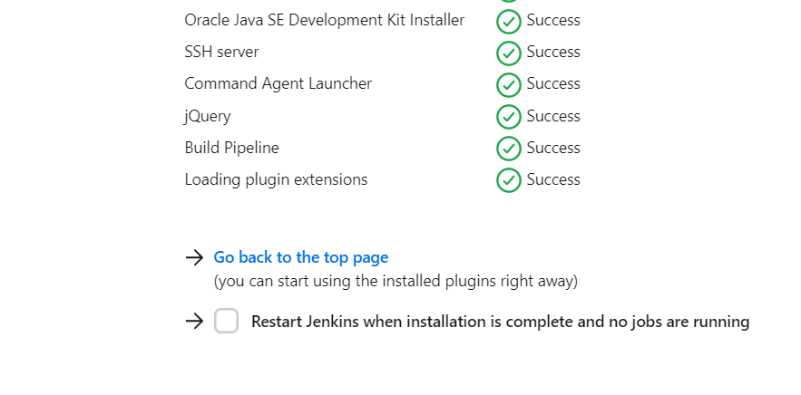

**Created 3 Dependent freestyle jobs: The First Job, The Second Job, The Third Job. After running The First Job, The Second Job should start automatically and then The Third Job should start automatically after completion of The Second Job that is main task.**

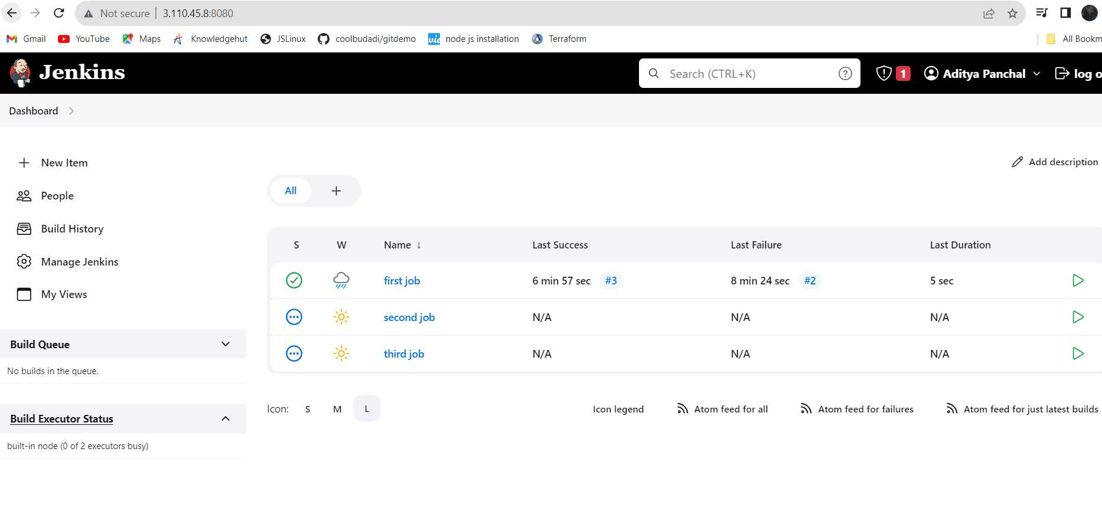

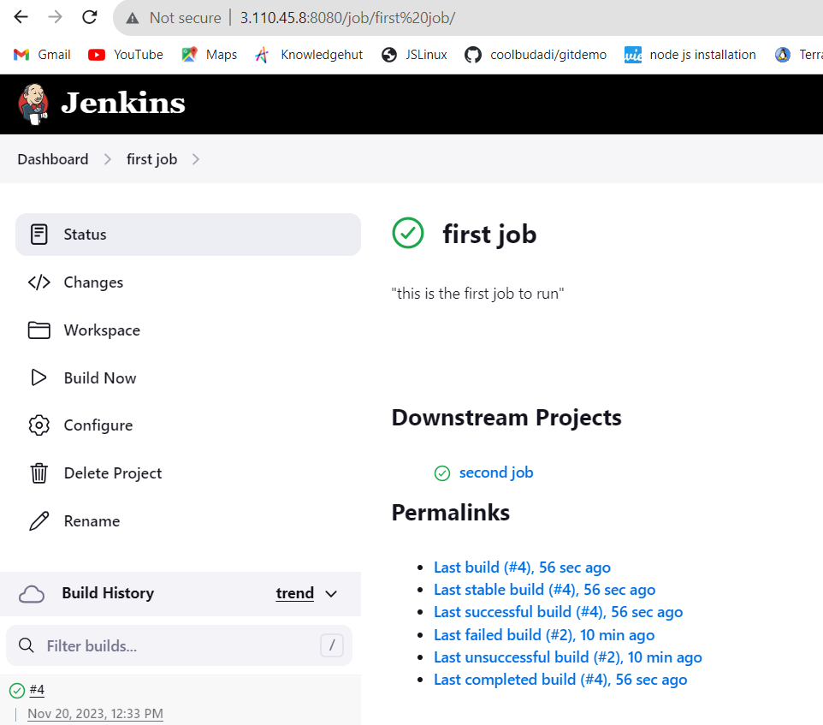

**After running first job it would triggered second job and after run second job third will executed.**

**Added options “post-build actions like “Build other projects” as below:**

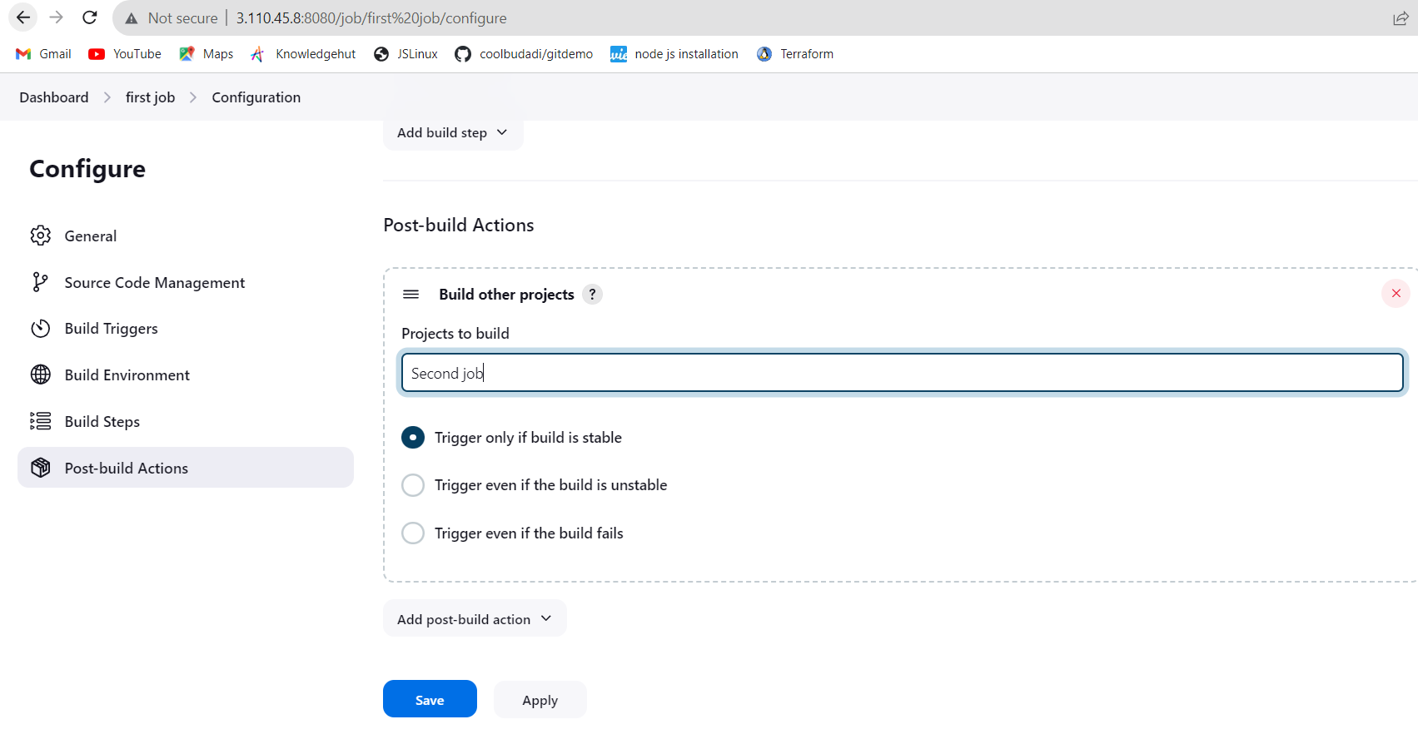

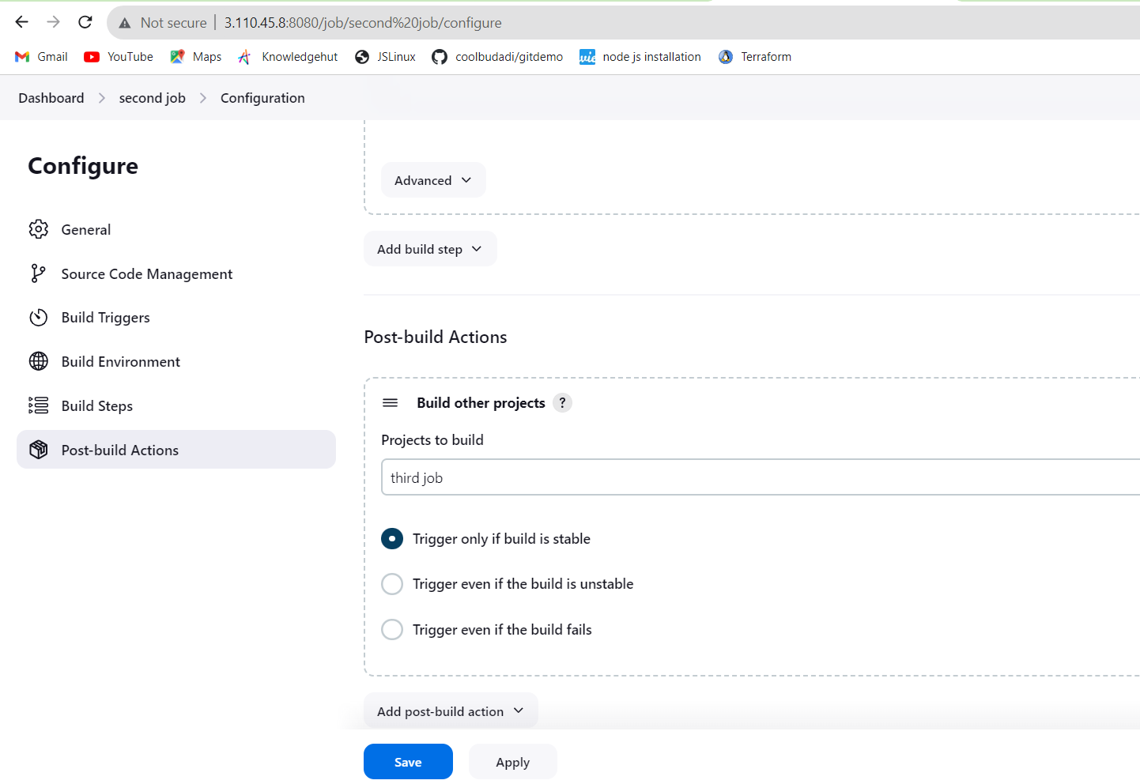

**Upstream downstream config should be set to “The First Job” and as we can see upstream project first and downstream project third job as below:**

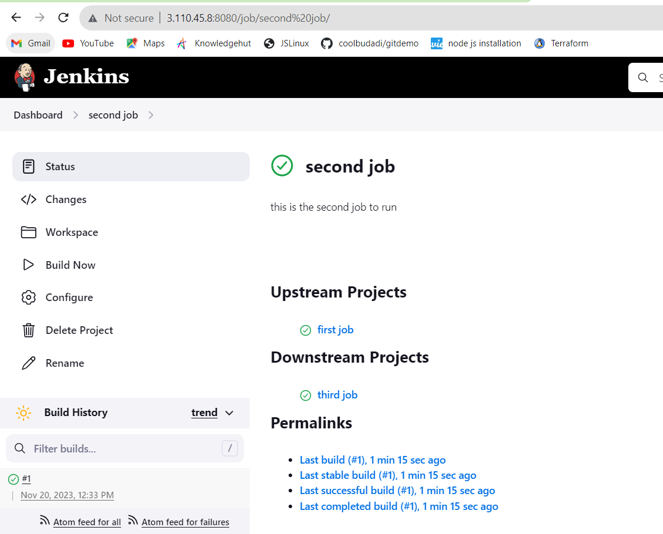

**We can see the output as below:**

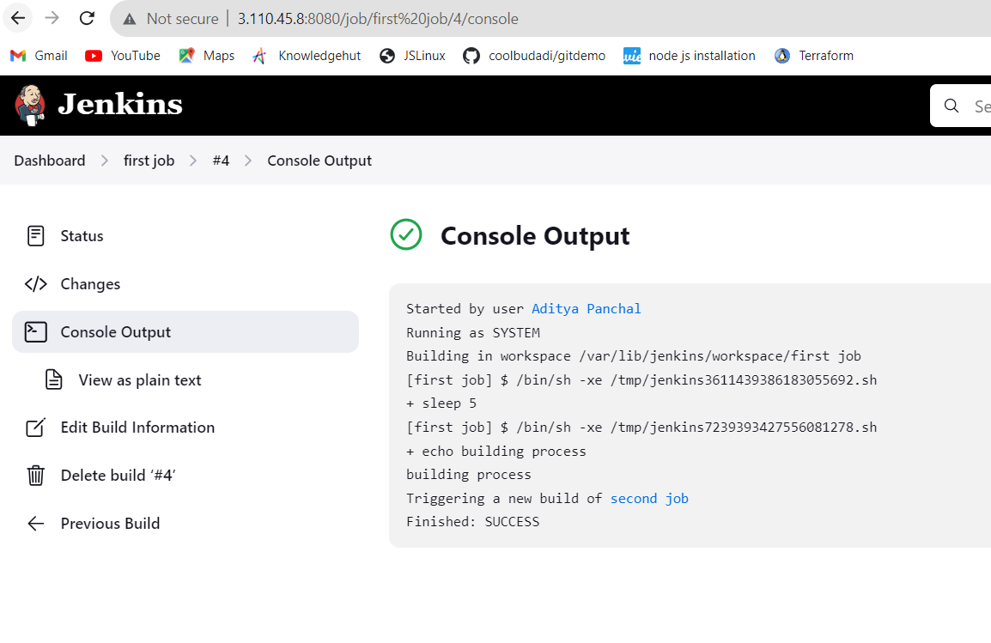

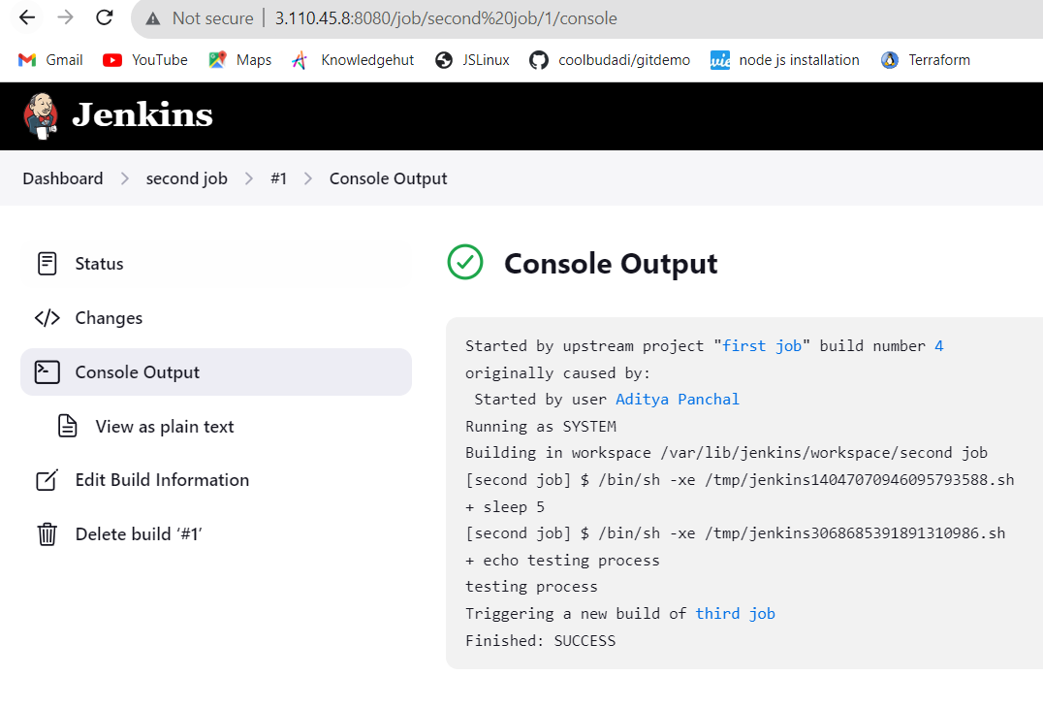

**Built a pipeline view in dashboard by adding new view and selecting “build pipeline view” and name “My pipeline view”**

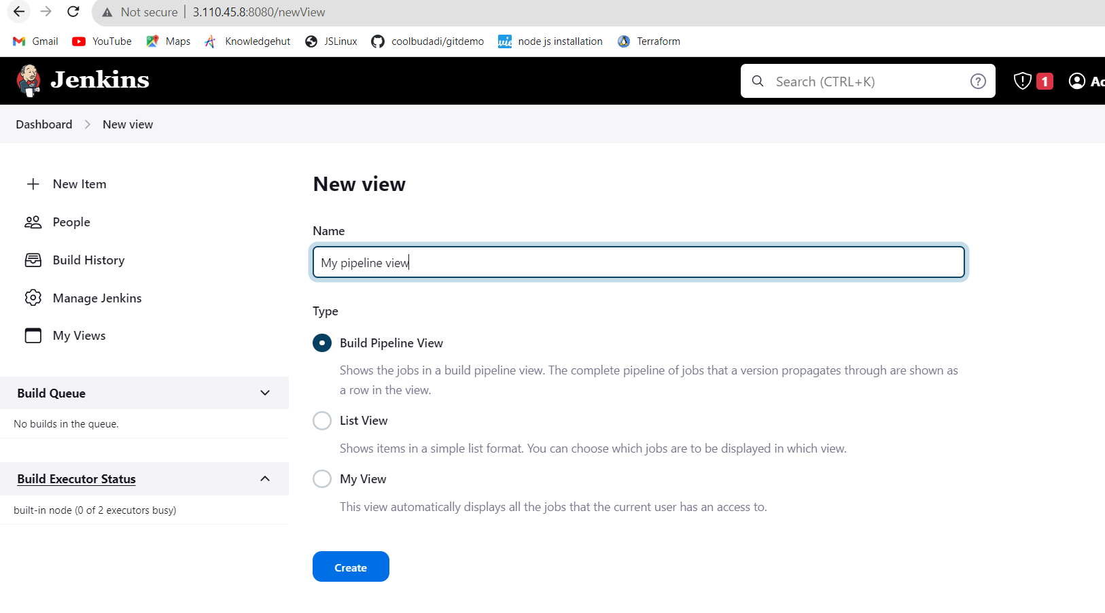

And No of Displayed builds = 10 as below:

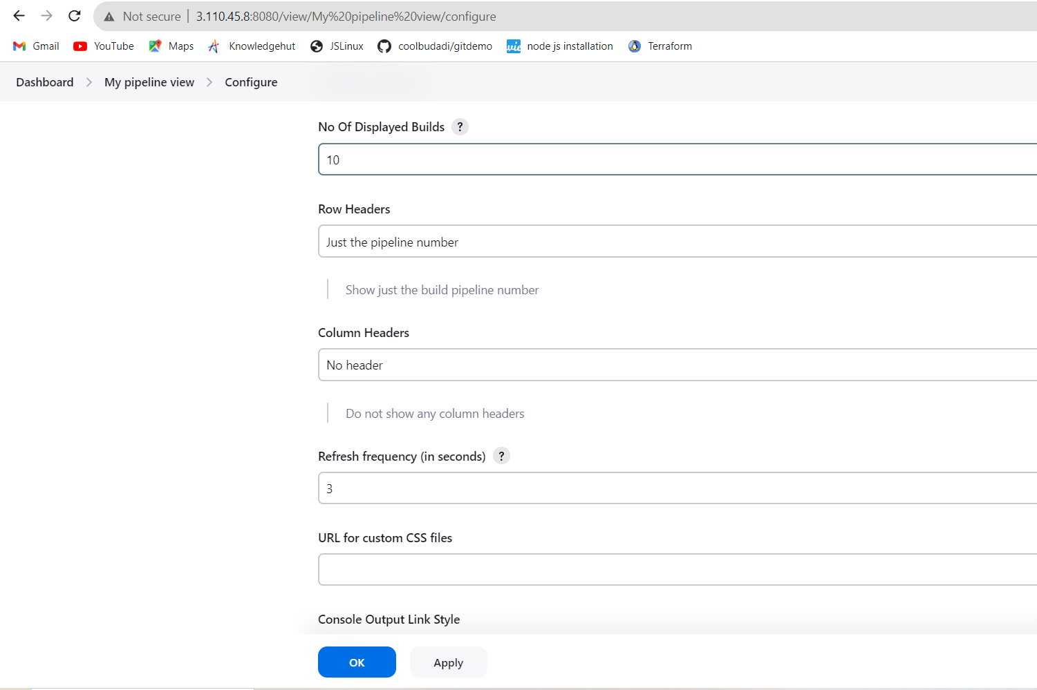

**Pipeline View and result:**

